**2022 ERAU REU: Ensemble Deep Learning** 



Embry-Riddle Aeronautical University

Nevada National Security Site

Rachel Swan

Jesse Adams, PhD

Dr. Berezovski

Margaret Lund, PhD

Support for the program has been provided by the National Science Foundation (NSF) through REU Award Number DMS - 2050754.

Nevada National Security Site (NNSS)

Nuclear weapons science Environmental protection

National security programs

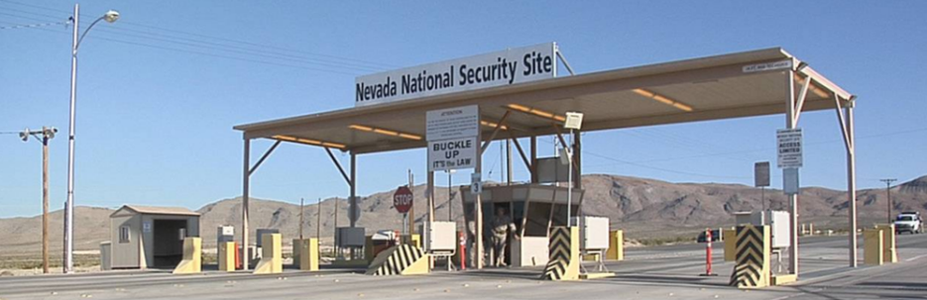

Problem Introduction 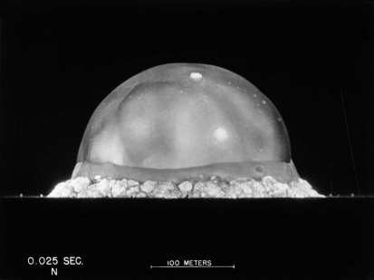

Radiographic image analysis using convolutional neural networks

Aids in NNSS tests analysis 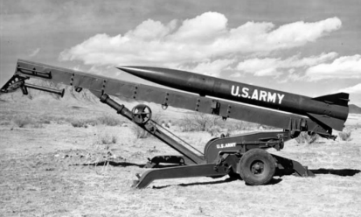

National security

Nuclear stockpile safety

Project Scope

Develop a network using Python and train it using image data Probability model and uncertainty quantification

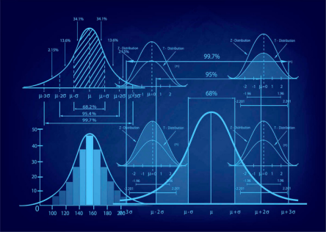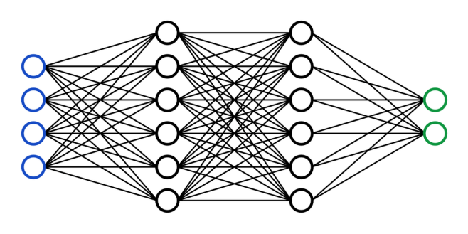

Initial Strategy 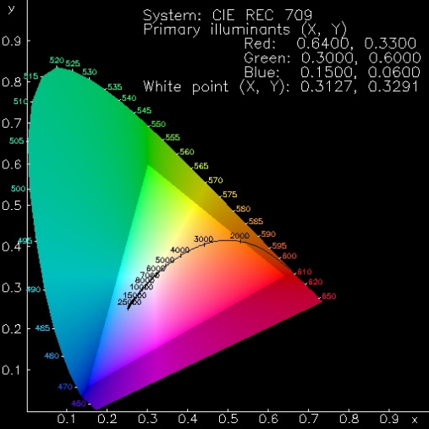

Develop neural networks and decide on an architecture

Create an ensemble and train the architecture *n* times

Start working on uncertainty quantification

Dataset: Absorption spectroscopy data for 179072 metal oxides

Image size: (64, 64, 3, 180902) 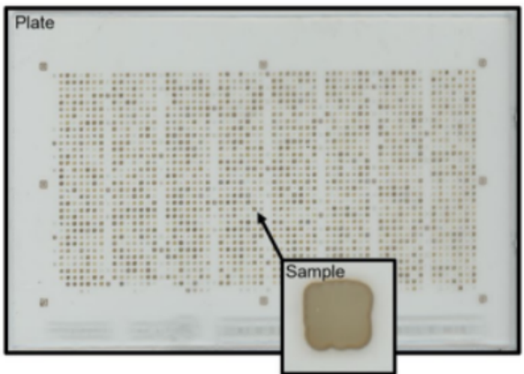

Channel values: RGB 

Normalized: 0-1 for every channel

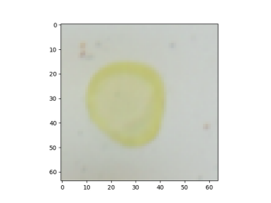

Stein, H. S., Soedarmadji, E., Newhouse, P. F., Guevarra, D. & Gregoire, J. M. Synthesis, optical imaging, and absorption spectroscopy data for 179072 metal oxides https://doi.org/10.6084/m9.fgshare.7502207 (2019).

Output 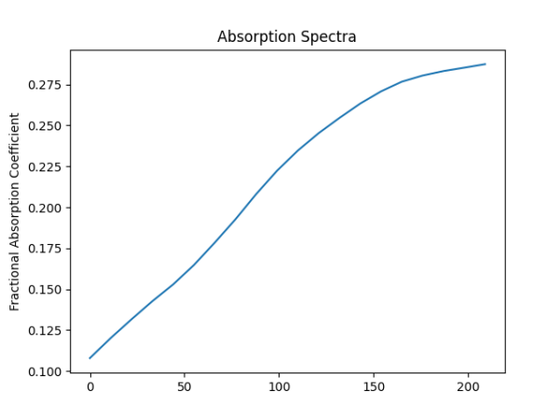

Spectra

Originally 220 values 20 values with linear interpolation between



Layers:

ModelSummary

Training:

1.

2. 3. 4. 5. 6. 7. 8.

Convolutional Dense 

Max Pooling Dropout

Flatten

Dense

Dense

Dense

90,000 images 80%training

20%validation Batchsize: 32

Epochs: earlystop Lossfunction: MSE

Ensemble Model Summary 

2 neural networks

Trained on 90,000 images

Batch size: 32

Epochs: early stop



Ensemble vs. Single NN



Uncertainty Quantification:

Gaussian Process Regression Non-parametric, Bayesian regression approach Gives 95% confidence interval for prediction

Next Steps

Implement uncertainty quantification approach